Crosby Stills Nash and Young - “Woodstock”
https://www.youtube.com/watch?v=g25DlXOWmMo
https://www.youtube.com/watch?v=q3SjqGfe-yM (visuals/Joni Mitchell)

Crosby, Stills & Nash (CSN) 1968–70, 1973, 1974, 1976, 1977–present was a folk rock supergroup of of David Crosby, Stephen Stills and Graham Nash. They are known as Crosby, Stills, Nash & Young (CSNY) when joined by a fourth member Neil Young. They are noted for their intricate vocal harmonies, often troublesome relationships, political activism, and lasting influence on American music and culture. All four members of CSNY have been inducted into the Rock and Roll Hall of Fame. All were former members of other famous groups which had broken up. Their music is ‘trippy’ in that it is gentle and loving. The trio's first album, Crosby, Stills & Nash, was released in May 1969 and was a major hit, spawning two Top 40 hit singles and receiving significant airplay on FM radio.
The group went on tour in the late summer of 1969 through the following January. Their first gig was on August 16, 1969 at the Auditorium Theater in Chicago, with Joni Mitchell as their opening act. They mentioned they were going to someplace called Woodstock the next day, but that they had no idea where that was. Their second time playing was at Woodstock, which was recorded as a movie and made them famous.
Their partnership was stressed by its success and the group freaked out after their tour in the summer of 1970. Concert recordings from that tour produced the 1971 double album Four Way Street. The four members did not come back together as a unit until a 1974 tour.

"Woodstock" written by Joni Mitchell  Well I came across a child of God,  he was walking along the road  And I asked him tell me where are you going,  and this is what he told me:  Well, I'm going down to Yasgur's farm, going to join in a rock and roll band.  Got to get back to the land, set my soul free.  CHORUS  We are stardust, we are golden,  we are billion year old carbon,  And we got to get ourselves  back to the garden.  Well, then can I walk beside you?  I have come to lose the smog.  And I feel like I'm a cog  in something turning.  And maybe it's the time of year,  yes, and maybe it's the time of man.  And I don't know who I am  but life is for learning.  CHORUS  We are stardust…  By the time we got to Woodstock,  we were half a million strong,  And everywhere was song and celebration.  And I dreamed I saw the bombers jet planes  riding shotgun in the sky,  Turning into butterflies above our nation.  We are stardust, we are golden, we are caught in the devil's bargain,  And we got to get ourselves  back to the garden. | came across = phrasal verb - found; discovered  a child of God = usually a religious person, here it may be a hippie who has an alternative but spiritual values  Yasgur’s farm = the name of the man who owned the land that allowed the Woodstock music festival – one of the largest and most important three days of music of rock’n roll  back to the land = expression, to connect to the earth again  billion year old carbon = humanity, human life; reference to diamonds too – the value of human life  stardust = reference to humanity being connected to all of life, including the stars  garden = Adam and Eve’s garden, paradise  smog = new word in the early 60s = fog+smoke from pollution  cog = small piece in a machine that helps the machine keep on moving – an unimportant part in one’s culture  and I saw the bombers jet planes = reference to Vietnam war with the US bombing much of that country  ride shotgun, a.(formerly) to ride atop a stagecoach as a shotgun-bearing guard; to protect or keep a watchful eye on something: riding shotgun over the nation's economy. (http://forum.wordreference.com/showthread.php?t=1766696)  in the devil’s bargain = human war where politicians make ‘bargains’ – financial arrangements – with the devil

Sixties Hippie Idioms
The 60s/Sixities were about sex, drugs n’ rock’n roll
The birth control pilled allowed women to enjoy sex without the fear of children; drugs were meant to turn on (open) the brain and person to other realities outside the limits of the taught culture – free the mind – and rock’n roll was the music that most young people had in common, thus linking them to the new youth culture that wanted change and was against ‘the Establishment’.
Turn on, tune in, drop out was the a counterculture phrase popularized by Timothy Leary in 1966. In 1967 Leary spoke at the Human Be-In, a gathering of 30,000 hippies in Golden Gate Park in San Francisco and uttered the famous phrase, which means to take mind opening drugs like LSD (turn on); tune into the world’s vibrations and reality (not what you were taught and brain washed with); and drop out of – leave – the rat race of making money.

Age of Aquarius / New Age was the astrological hope for mental and spiritual development of humanity where emotions, spirituality, kindness, helping, etc. rivaled the old consumerism, individualism of the US culture and its mental enslavement; to create a new culture of freedom to think and try new ideas.

Far out = phrasal verb for s.t. that is great, unusual or special, as if it is far out in the galaxy.

Bummer = very bad, used to refer to an LSD trip/experience that was bad then applied to negative feelings.

ripped off = phrasal verb to have s.o. steal s.t. from a person, such as to rip off lyrics from one song to use in another without telling people.

freak out = to lose self-control; to get very upset.

high = to experience extreme happiness, usually by taking drugs.

get it together = expression to advise s.o. from freaking out to control one’s emotions or choices in life; to change one’s life for the better.
Where are you coming from? What is your background about what we are talking about? This statement says people ‘come from’ different backgrounds so have different ideas about life. A Vietnam soldier will have a very different point of view from when compared to an anti-war protester who never was in the military.

Janis Joplin - Mercedes Benz
https://www.youtube.com/watch?v=5ddnwyyGo4s

This song seems to be about money, but Joplin is making fun of the money culture.

Oh Lord,  won't you buy me a Mercedes Benz?  My friends all drive Porsches,  I must make amends.  Worked hard all my lifetime,  no help from my friends,  So Lord,  won't you buy me a Mercedes Benz?  Oh Lord,  won't you buy me a color TV?  Dialing For Dollars is trying to find me.  I wait for delivery each day until three,  So oh Lord, won't you buy me a color TV?  Oh Lord,  won't you buy me a night on the town?  I'm counting on you, Lord,  please don't let me down.  Prove that you love me  and buy the next round,  Oh Lord,  won't you buy me a night on the town?  Everybody!  Oh Lord,  won't you buy me a Mercedes Benz?  My friends all drive Porsches,  I must make amends,  Worked hard all my lifetime,  no help from my friends,  So oh Lord,  won't you buy me a Mercedes Benz?  That's it! | oh Lord = beginning of a prayer (US culture traditionally was mostly Christian at this time)  Mercedes Benz = extremely expensive car that shows a person is rich  Porsches = another extremely expensive kind of car  make amends = change the balance so I can keep up with the Joneses  color TV = TV was first only in black and white. In the late 60s and early 70s, color TVs became popular, but were expensive  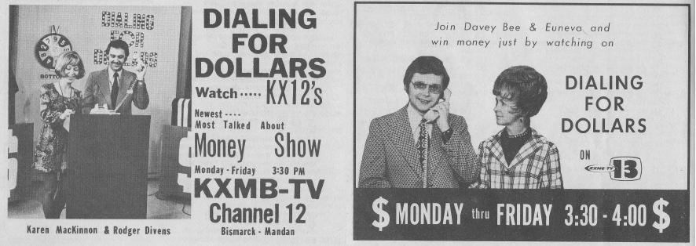  Dialing for Dollars = radio program popular in the 1950s, 60s and 70s in which the radio announcers ‘dailed’ (telephoned) a person and if the person knew a ‘password’ told at the beginning of the show, they would win money  I'm counting on you = expression, depending on you to do the right thing  let me down = disappoint  and buy the next round = when people go to bars in a group, the next round is the next set of alcoholic drinks that go around the group they are with  night on the town = idiom, to spend a lot of money enjoying the nightlife of a town – restaurants, dance places, drinks, etc.

Shania Twain

Ka-Ching

https://www.youtube.com/watch?v=DQKuFDL-kos

Any Man of Mine

https://www.youtube.com/watch?v=qiwGmTNPYi8

That Don’t Impress Me Much
https://www.youtube.com/watch?v=4anjoS0d_mo
I’m Gonna Get Ya
https://www.youtube.com/watch?v=Tb90z8Whxak

"Ka-Ching"  We live in a greedy little world--  that teaches every little boy and girl  To earn as much as they can possibly--  then turn around and  Spend it foolishly  We've created us a credit card mess  We spend the money that we don't possess  Our religion is to go and blow it all  So it's shoppin' every Sunday at the mall  All we ever want is more  A lot more than we had before  So take me to the nearest store  Chorus  Can you hear it ring  It makes you wanna sing  It's such a beautiful thing--Ka-ching!  Lots of diamond rings  The happiness it brings  You'll live like a king  With lots of money and things  When you're broke go and get a loan  Take out another mortgage on your home  Consolidate so you can afford  To go and spend some more  when you get bored  Chorus  All we ever want is more  A lot more than we had before  So take me to the nearest store  Let's swing  Dig deeper in your pocket  Oh, yeah, ha  Come on, I know you've got it  Dig deeper in your wallet  Oh / All we ever want is more  A lot more than we had before  So take me to the nearest store  Chorus  Can you hear it ring  It makes you wanna sing  You'll live like a king  With lots of money and things  Ka-ching! | ka-ching = sound of cash register at a store when it takes money from a customer (picture, old fashioned cash register)  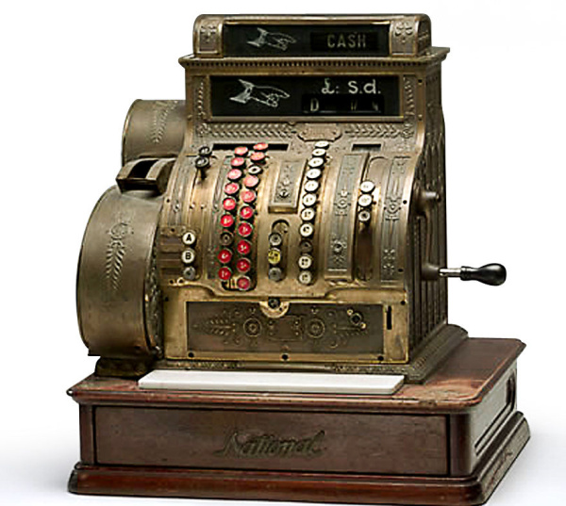  greedy= to want too much money or too many things  earn = to work for money  foolishly = not wisely; stupidly  credit card = agreement with a company to pay back money loaned over a period of time. The company gives people a plastic credit card (to live as if you have more money than you really do, helps people go into debt)  blow it all = spend all one’s money foolishly (opposite of saving money)  broke = have no money  loan = borrow money from a bank, friend, or credit card  mortgage = large amount of money to be paid to a bank over 20 or more years  consolidate = to put loans from different banks, credit cards, etc. into one big ‘consolidated’ loan  pocket = place to put things on clothing, in the front and back of jeans  wallet = small object, often made of leather, to keep money, credit and bank cards, and photos, etc.

Money Idioms – from http://www.idiomconnection.com/money.html
- for all the tea in China – China mostly sold tea many years ago, so this was for a lot of money
- no money, no honey – male expression that means if a man has no money, he will not attract a woman (honey)
- money (or love) makes the world go round – money (or love) is what makes life happen
- as phony as a three-dollar bill - phony, not genuine
The man who was asking for donations for the charity was as phony as a three-dollar bill.
- as poor as a church mouse - very poor
The young mother is as poor as a church mouse and she has little money to feed her family.
- at all costs - at any expense of time or effort or money
We plan to send our child to a good school at all costs.
- back on one`s feet - to return to good financial health
My sister is back on her feet after losing her job last year.
- beyond one's means - more than one can afford
The young man was living beyond his means before he got his first job.
- born with a silver spoon in one`s mouth- to be born to wealth and comfort, to be born rich
The new student in our class was born with a silver spoon in his mouth and has had an easy life.
- bread and butter- one's income, the source of someone's food
The man's business is his bread and butter and he works very hard to make it successful.
- bring home the bacon- to earn the family living, to earn a salary
I have been working hard all month bringing home the bacon for my family.
- buy off (someone) or buy (someone) off- to give money to someone to stop them from doing their duty (corruption) The man tried to buy off the politician but the politician refused to agree to the plan.
- buy (something) for a song - to buy something cheaply - I was able to buy my first house for a song.
- cash-and-carry- selling something for cash only and with no delivery
We were able to get a good price on a sofa in a cash-and-carry deal at the furniture store.
- cash in on (something)- to make money from an opportunity
The former basketball player cashed in on his popularity to open a very successful restaurant.
- caught short- to not have enough money when you need it
I was caught short and had to borrow some money from my father last week.
- cheapskate- a person who will not spend much money, a stingy person
My friend is a cheapskate and will not go to a movie with me.
- chicken feed- a small amount of money - The amount of money that I paid for the used car was chicken feed.
- closefisted (with money)- to be very stingy with money
The man is closefisted with money and will not spend it.
- control the purse strings- to be in charge of the money in a business or a household
My sister controls the purse strings in her family.
- cost a pretty penny- to cost a lot of money - It is going to cost a pretty penny to get my car fixed.
- cost an arm and a leg- to cost a lot of money - My new television cost an arm and a leg.
- cut (someone) off without a penny- to stop giving someone a regular amount of money, to leave someone no money in a will, as a parent cuts off a child who does not work or study, or misbehaves in a major way - The wealthy businessman cut his son off without a penny when the young man refused to work hard.
- deadbeat- a person who never pays the money that he or she owes
Recently, the government is trying to solve the problem of deadbeat fathers who do not support their families.
- a dime a dozen- easy to get and therefore of little value -
Used computers are a dime a dozen and they have little value.
- dirt cheap- extremely cheap - The land was dirt cheap when we bought it.
- down-and-out- having no money - My friend was down-and-out for many years before he got a job.
- Dutch treat- a situation where each person pays his or her own share of the expenses
The movie was a Dutch treat so I did not have to pay for my date.
- easy money- money that you do not need to work hard to get
I was able to make some easy money from my job during the summer.
- face value- the value or price printed on a stamp or bond or paper money
The face value of the stamp was very low but it was worth a lot of money.
- feel like a million dollars/bucks- to feel wonderful, to feel well and healthy
Although I have been sick for a few weeks I feel like a million dollars today.
- flat broke- to have no money at all - I am flat broke and do not have enough money to pay my rent.
- a fool and his money are soon parted- if a person acts unwisely with money he or she will soon lose it A fool and his money are soon parted and when the young man got the money from his father he soon spent it.
- foot the bill- to pay for something
My sister will foot the bill for her daughter's education if she decides to go to university.
- for a song- at a low price, cheaply - We bought the car for a song and will use it on our holidays.
- (not) for love or money- not for anything, not for any price (usually used in the negative)
I would not want to have that man's job for love or money.
- for peanuts- for very little money - The man had no money and was willing to work for peanuts.
- fork out money (for something) or fork money out (for something)- to pay for something
I had to fork out much money to get my car fixed.
- fork over (some money) or fork (some money) over- to pay money for something
I forked over much money for the painting that is hanging on my wall.
- from rags to riches- from poverty to wealth – The man went from rags to riches with his hard work.
- get along on a shoestring- to be able to live on very little money
The woman was forced to get along on a shoestring when she was a student.
- go Dutch- to share in the cost of a meal or some other event
We decided to go Dutch when we went to the restaurant for dinner.
- grease (someone`s) palm- to pay for a special favor or for extra help, to bribe someone
We had to grease the palm of the hotel manager to get a room.
- a handout- a gift of money (usually from the government)
The bus company has received many handouts from the government.
- have money to burn- to have very much money, to have more money than is needed
My aunt has money to burn and she is always travelling somewhere.
- have sticky fingers- to be a thief
The new employee has sticky fingers and many things in the store have disappeared.
- have the Midas touch- to have the ability to make money easily (King Midas turned everything that he touched into gold)
My uncle has the Midas touch and every business that he starts makes a lot of money.
- highway robbery- the charging of a high price for something; the price is unreasonably too expensive - The amount of money that the company is charging for its services is highway robbery.
- hit the jackpot- to make a lot of money suddenly (usually from gambling)
We hit the jackpot at the casino and came home with much money.

